**Guided Solution for Tutorial 1**

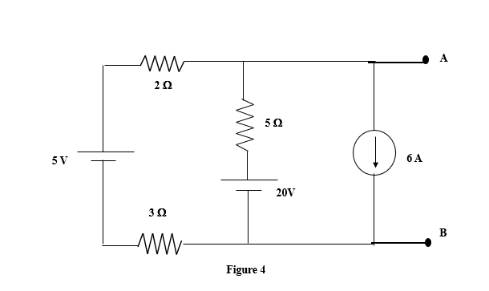**Q4**

1. Convert the 5V voltage source and 20 V voltage source to current source. Draw the new

circuit diagram.

2. Then find the algebraic sum of the 3 currents sources.

3. Use the reciprocate formula to find the overall resistance.

4. Draw the diagram with a resultant current source and resistance.